Power System Grounding
Norbert Doerry
November 21, 2025
- Introduction
Onboard ship, electrical grounding refers to the practice of creating an electrical connection from an electrically conducting part, either directly with a conductor, or via an impedance, to the hull of the ship. As detailed in IEEE Std. 45.3 and IEEE Std. 45.1, grounding is implemented for five different reasons:
- Power system grounding to protect insulation systems on shipboard power system cabling, transformers, motors, generators, and other components.
- Equipment grounding (protective earthing) for personnel safety implemented by bonding all exposed conductors together so that they are the same voltage.
- Common mode grounding to provide a designed path for higher frequency common mode currents instead of through parasitic impedances. Typically implemented through Electromagnetic Interference (EMI) filters.
- Cathodic protection to inhibit galvanic corrosion of the hull and other ship components.
- Lightning protection to provide a designed path for lightning currents to pass through the ship’s hull to the water.
While this document focuses on power system grounding, all of the grounding implementations interact with each other to some extent.
Shipboard power systems have historically been ungrounded. In an ungrounded power system, an electrical connection, either directly or via a power system component, between the power system conductors and the hull of the ship does not intentionally exist. The principal advantage of an ungrounded power system is that continued operation with a single line to ground fault is possible. A line to ground fault as an inadvertent electrical connection between a power system conductor and the hull of the ship; a ground fault typically occurs due to an insulation failure, component failure, flooding, or conducting debris. The principal disadvantages of an ungrounded power system are that electrical insulation must be thicker than for solidly grounded systems, and under certain intermittent ground fault conditions in ac systems, significant line to ground over-voltages may occur.
Terrestrial power systems typically are solidly grounded; the neutral conductor is solidly connected to ground. A ground fault results in very high fault currents that enable the traditional fault protection system (coordinated circuit breakers) to open the circuit breaker closest to the ground fault. In shipboard applications, having mission critical equipment trip offline during critical operations may not be ideal; the safety of the ship is likely to be more important than clearing the ground fault. Consequently, solidly grounded systems are typically not employed for portions of the power system supplying mission critical systems. On the other hand, some commercial off the shelf equipment (COTS) designed for operation with the terrestrial power system, may not function, or function safely when connected to a power system that is not solidly grounded. Hence it may be desirable for portions of the power system that supply non-mission critical systems to be solidly grounded.
High resistance grounding inserts a resistor between the power system neutral and ground. In ac systems, the value of the resistor is chosen to limit fault current such that the fault protection system does not automatically clear the fault and such that transients are quickly damped during intermittent faults to preclude severe over-voltages. High resistance grounding is typically employed in ac systems with voltages about 1 kV and in some systems below 1 kV. In dc systems, the value of the resistor is chosen to be about an order of magnitude less than the design insulation resistance to keep the neutral voltage near the hull voltage should the insulation system have unbalanced conductor to ground resistances.
Each of the different grounding methods responds differently to line to ground faults and has different methods for locating and isolating the line to ground faults.
If a ground fault on one power system does not result in a change to the neutral to ground impedance of another power system, the two power systems are said to be separately derived systems. Separately derived systems are typically either totally disconnected from each other, or connected with a component that incorporates a transformer in the main power path. The grounding methods employed by two separately derived systems may or may not be the same.
For further information on shipboard power system grounding, see Doerry, Islam, and Prousalidis (2025), IEEE Std. 45.1, and IEEE Std. 45.3. For power system grounding in general, see IEEE Std 3003.1.
- Grounding methods
  - Ungrounded
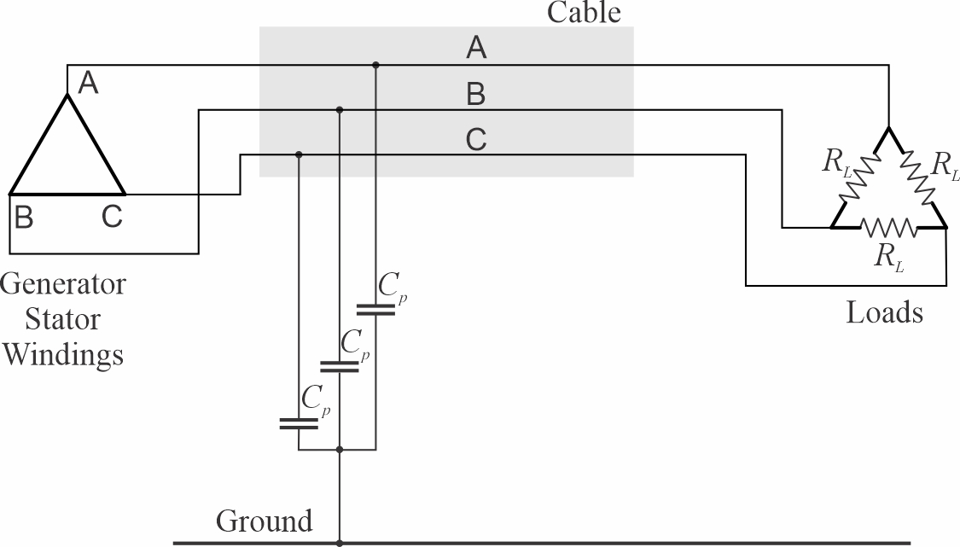
Figure 1: Ungrounded Power System
Figure 1 depicts an ungrounded power system. Although there are no intentional connections between the power system conductors and ground, parasitic capacitances (C_{p}) between the conductors and ground make the system effectively capacitively grounded. The capacitance is largely due to line to ground capacitance of the cable conductors and line to ground capacitances within EMI filters. Since the parasitic capacitances are typically equal for each phase, the sum of the currents through the parasitic capacitances is zero when the system is not faulted.
In an ungrounded system, generator stator windings are typically connected as delta windings (as shown in Figure 1). Likewise, loads are usually connected as delta loads.
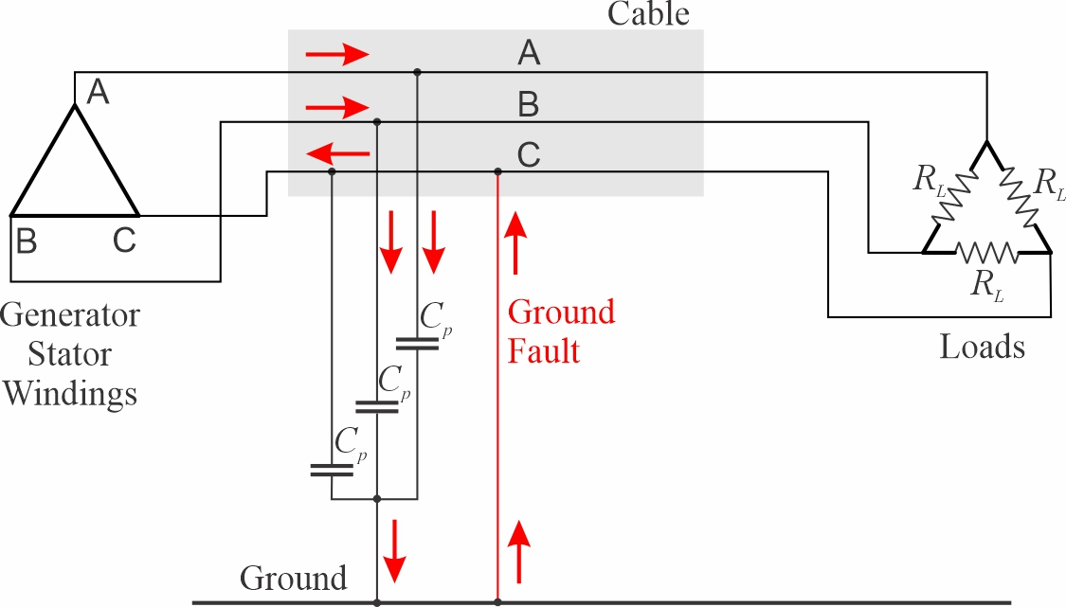
Figure 2: Current path during ground fault on an ungrounded system.
Figure 2 depicts the current path during a ground fault on an ungrounded system. The ground fault current starts in the unfaulted phases, flows through the parasitic capacitances, up through the ground fault, and returns to the faulted phase. The magnitude of the ground fault current is determined by the line to line (or line to neutral) voltage and the magnitude of the parasitic capacitance.
$\left|i_{fault}\right|=\left(3ωC_{p}\right)\frac{V_{line_to_line}}{\sqrt{3}}=\left(3ωC_{p}\right)V_{line_to_neutral}$ [1]
In ungrounded shipboard power systems, ground fault currents can be expected to have magnitudes in the amps to tens of amps.
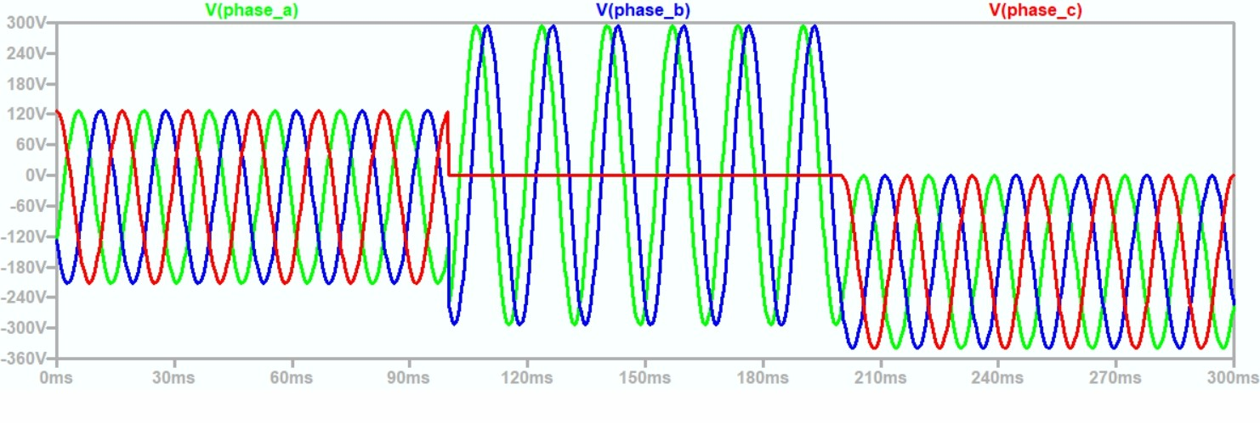
Figure 3: Line to ground voltages for ungrounded system during ground fault (20251117 ungrounded.asc)
Figure 3 depicts the line to ground voltages before, during, and after a ground fault on an ungrounded system. Prior to the ground fault, the line to ground voltages are centered around ground (0 volts). During the ground fault, the line to ground voltage on the faulted phase is zero, and the remaining two unfaulted phases have a line to ground voltage equal to the line-to-line voltage in magnitude and 60 electrical degrees apart. Once the fault clears, the line to ground voltages of all phases have the same shape as the unfaulted condition, but with a dc offset. The dc offset is due to trapped charge in the parasitic capacitance when the fault clears. Over time, this dc offset will decay to zero.
Other than possibly very fast transients (not modelled in the simplified circuit used to generate Figure 3), the line-to-line and line-to-neutral voltages are not impacted by the ground fault. Similarly, the current into the load is also not impacted by the ground fault. The lack of impact to the line-to-line voltages and line currents during a ground fault is one of the key reasons ungrounded systems have been used onboard ships.
One drawback to ungrounded systems is the need for the insulation system to be rated for the line-to-line voltage rather than the line-to-ground voltage requirement for solidly grounded systems. Another drawback is that under very specific conditions, an intermittent ground fault that restrikes once or twice per cycle can result is transient voltages with magnitudes several times the nominal line-to-neutral voltage.
  - High resistance grounded
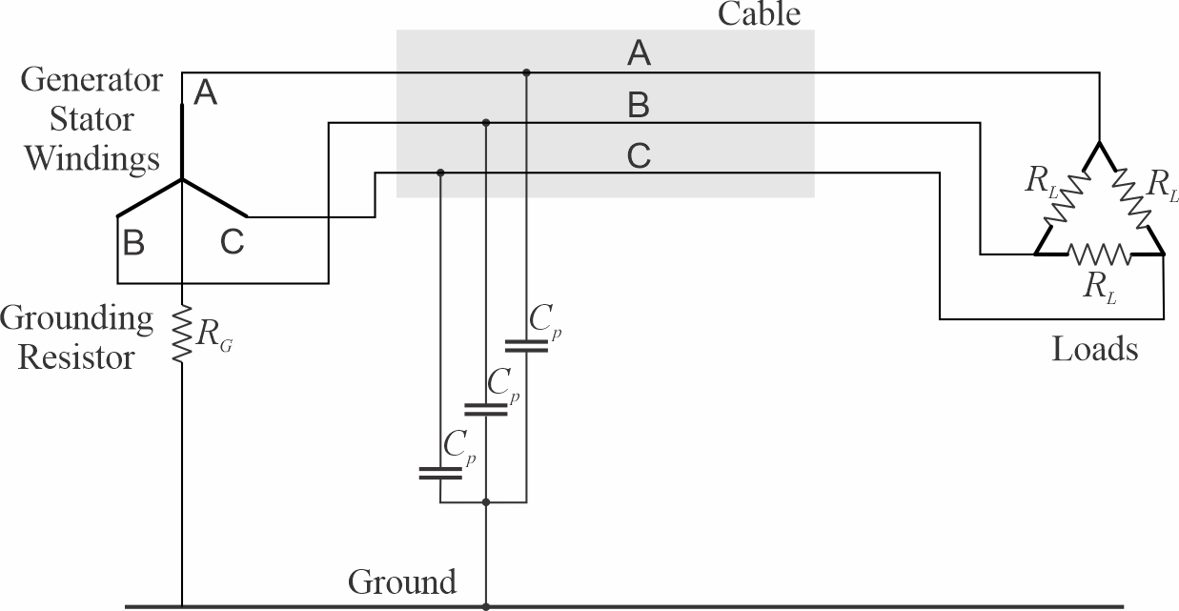
Figure 4: High resistance grounded power system
Figure 4 depicts a high resistance grounded power system. While a wye-connected generator is depicted, a delta connected generator may be employed if an additional grounding transformer is used to establish a neutral conductor. See Doerry, Islam, and Prousalidis (2025) for details on the design and operation of grounding transformers. The grounding resistor connects the wye connection point of the generator stator windings to ground. The grounding resistor value is high enough so that in if a ground fault is present, the magnitude of the ground fault current is low enough to not cause a circuit breaker to trip. The grounding resistor value is low enough to dampen out transients during intermittent ground faults to preclude damaging transient over voltages. The ground resistance is normally chosen to nearly equal the impedance of the paralleled parasitic capacitances as shown in [2].
$R_{G}≈\frac{1}{3ωC_{p}}$ [2]
The resulting RC time constant ($τ)$ that determines how fast transients decay is given by [3] and [4]. Equation [4] shows that in one period (T) of the voltage waveform, transients will have experienced over six time constants of decay. In one half of T, transients will have experienced over three time constants of decay. Transients from an intermittent ground fault will likely have decayed to less than 5% of their original value between ground faults.
$τ=3C_{p}R_{G}≈\frac{1}{ω}=\frac{1}{2π}T$ [3]
$T≈ 2πτ$ [4]
If the grounding resistor value is chosen per [2], then the ground fault current will be the sum of the currents through the parasitic capacitances and the grounding resistor; these two currents have the same magnitude, but are 90 electrical degrees out of phase. Hence the ground fault current is $\sqrt{2}$ times what the ground fault current would be in an ungrounded system as shown in [5].
$\left|i_{fault}\right|=\frac{V_{line_to_line}}{\sqrt{3}}\sqrt{{\left(3ωC_{p}\right)}^{2}+{\left(\frac{1}{R_{G}}\right)}^{2}}≈\sqrt{2}\left(\frac{V_{line_to_line}}{\sqrt{3}}\right)\left(3ωC_{p}\right)$ [5]
Figure 5 depicts the line to ground voltages before, during, and after a ground fault on a high resistance grounded system. The waveforms before and during the ground fault are nearly identical to the ungrounded case. Once the ground fault clears however, the trapped charge causing the dc offset in the ungrounded case is quickly dissipated by the grounding resistor; the voltage waveforms return to their pre-faulted states within a cycle after the ground fault clears.
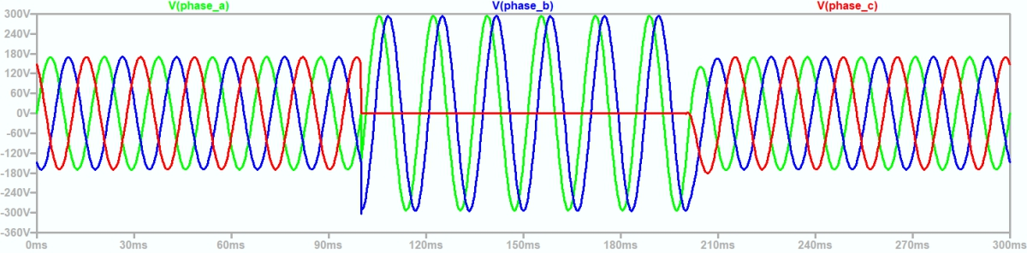
Figure 5: Line to ground voltages for high resistance grounded system during ground fault (20251118 hrg - 1.asc)
  - Solidly grounded
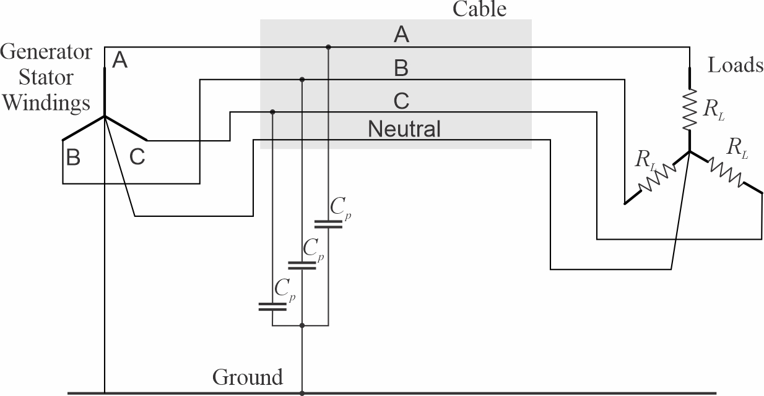
Figure 6: Solidly grounded power system
Figure 6 depicts a 4-wire solidly grounded system. In addition to the three phase conductors, a neutral conductor connects the wye connection point of the wye connected loads and the wye connection point of generator stator windings. The wye connection point of the generator is solidly connected to ground. Although not depicted, four wire systems can also have higher voltage loads connected between phases.
One advantage of solidly grounded systems is that line to neutral loads only require line to ground insulation systems rated for the line-to-neutral voltage and not line-to-line voltage as required by the other grounding systems. Another advantage is that solidly grounded systems are used in terrestrial power systems; commercial equipment is generally designed to work with solidly grounded systems. Commercial equipment should be tested before installation in an ungrounded or high resistance grounded system to ensure proper operation.
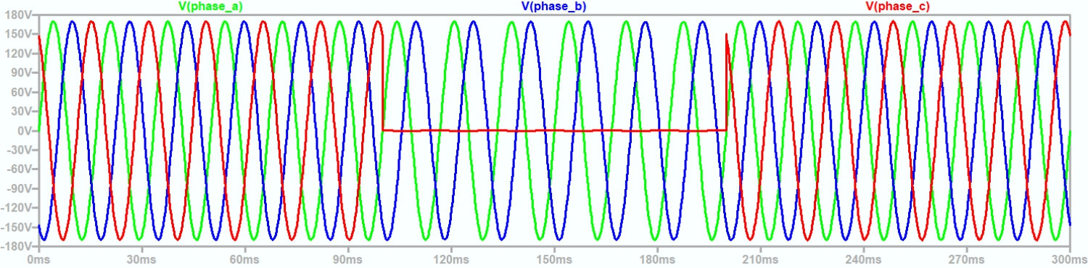
Figure 7: Line to ground voltages for solidly grounded system during ground fault (20251118 solid - 1.asc)
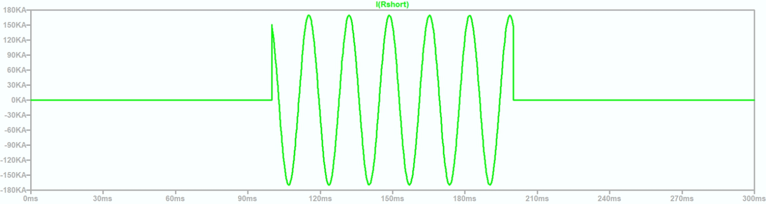
Figure 8: Fault current for solidly grounded system during ground fault (20251118 solid - 1.asc)
Figure 7 depicts the line to ground voltages for a solidly grounded system before, during, and after a ground fault. During the ground fault, the line to ground voltage of the faulted phase is zero as expected. The wye connected loads connected to the faulted phase experience a power interruption. The ground fault current is very high as shown in Figure 8. The magnitude of the fault current is determined by generator and cable impedances. In any case, the fault current magnitude is sufficiently high to trip the appropriate circuit breakers.
- Common mode
  - Introduction
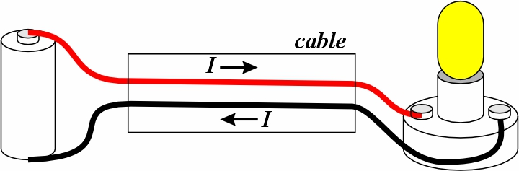
Figure 9: Shipboard differential mode circuit
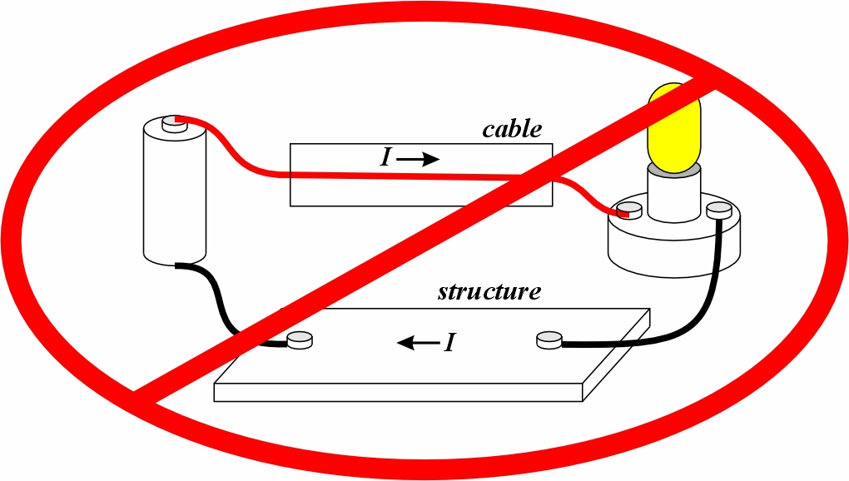
Figure 10: Structure should not be used as a current carrying conductor in shipboard power systems
As depicted in Figure 9, shipboard power systems are designed for the differential mode. In the differential mode, cables contain conductors that include all the current paths for normal operation; the currents in the power conductors (measured in the same direction) sum to zero. This in contrast to Figure 10 where one current path is through the structure and not in a cable conductor; the current in the cable is not designed to be zero.
With a few exceptions, current should not be designed to flow through the hull of the ship. Current flowing through the hull of the ship can result in hull corrosion, localized heating, sparks that can ignite flammable fumes, etc.
While ship power systems are designed for the differential mode, there are conditions where the sum of the currents in the conductors of a cable do not sum to zero. This is the realm of common-mode. Common-mode voltages and currents are a property of a set of conductors (although the set can contain only a single conductor). Many times, one cannot measure common mode currents or voltages; they must be calculated based on measurements on each of the conductors. Common mode current for a set of conductors is the sum of the currents in each of the conductors. The common mode voltage is the average value of the voltages of the conductors with respect to a reference voltage.
For a set of conductors, the neutral point is the voltage reference where the CM voltage is zero. The voltage of the neutral point with respect to another voltage is thus the same as the CM voltage of the set of conductors and may be called the neutral voltage.
Certain conductors, such as those connected to the wye point of wye connected windings or loads may be called neutral conductors because their voltage is intended to be near the neutral voltage for a set of conductors. At any particular time however, the voltage of the neutral conductor may deviate from the neutral voltage; the neutral voltage is a calculated quantity based on the voltages of the set of conductors. In some exceptional cases, the term neutral conductor is applied to a conductor that is never at the neutral voltage for a set of conductors (120 volt ac wiring in residential systems for example). Do not automatically assume a neutral conductor is at the neutral voltage.
If we examine the parasitic capacitances in Figure 11, the common mode voltage V_{CM} across the capacitors is given by [6] and the common mode current through the three capacitors is given by [7].
$V_{CM}=\frac{1}{3}\left(V_{A}+V_{B}+V_{C}\right)$ [6]
$I_{CM}=I_{CpA}+I_{CpB}+I_{CpC}$ [7]
It can be easily shown that:
$V_{CM}={-I}_{CM}\left(\frac{1}{ω3C_{p}}\right)\hat{j}$ [6]
The common mode impedance of the three capacitors is thus equal to the impedance of the three capacitors in parallel. If there is no common mode voltage, then there will be no common mode current flowing through the parasitic capacitances. Without a common mode voltage across the capacitors, the currents through the capacitors sum to zero.
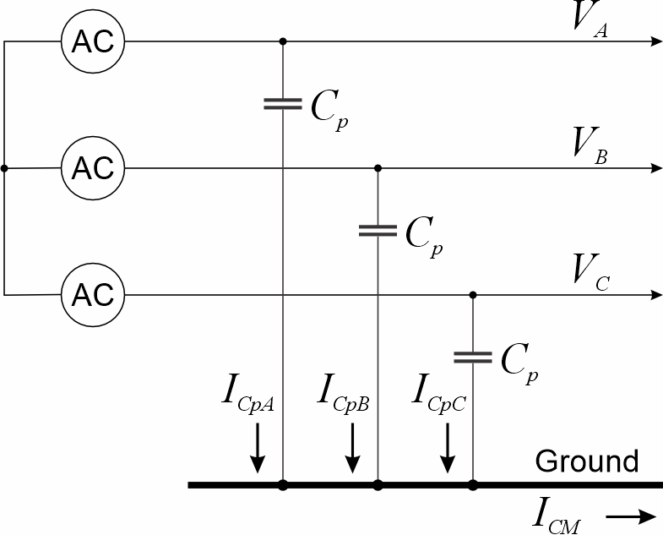
Figure 11: Common mode voltages and currents
  - Ground fault common mode voltages and currents
A ground fault in an ungrouded or high resistance grounded power system sets the common mode voltage between the neutral of the cable and ground to the negative of the line to neutral voltage of the faulted phase. The fault current is equal to the common mode current through the parasitic capacitances and can be solved for using the common mode equivalent circuit depicted in Figure 12. An ac source is used to model the ground fault; it has a value equal to the negative line to neutral voltage of the faulted bus. The common mode equivalent capacitance equal to the parallel combination of the parasitic capacitances completes the common mode circuit; the common mode current / fault current may then be solved for and is equivalent to [1]. The addition of a high resistance ground as depicted in Figure 13 between the neutral and ground enables calculation of the fault current and is equivalent to [5].
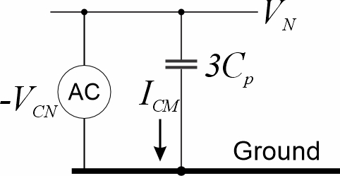
Figure 12: Common mode equivalent circuit for ungrounded power system with ground fault
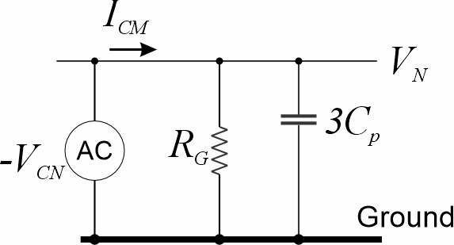
Figure 13 Common mode equivalent circuit for ungrounded power system with ground fault
The use of common mode modeling can greatly simplify the analysis required to calculate ground fault currents and the flow of fault current through a power system network. While the examples shown here are simple representations, the concept may be applied for more complex topologies.
- Ground fault detection, localization and isolation
  - Ungrounded systems
Detecting a ground fault in an ungrounded system has customarily been accomplished through ground detection lamps as shown in Figure 14. The three lamps are connected in wye, with the wye common point connected to ground through a normally closed switch as depicted in Figure 15. Without a ground fault, all of the lamps are dimly lit; they each are powered by the line-to-neutral voltage. With a ground fault, the faulted phase’s lamp will not be lit and the other two lamps will be brightly lit; the unfaulted phase lamps are powered by the line-to-line voltage. One can discriminate between a true ground fault and a burned out lamp by depressing the test switch; when depressed, all lamps should be dimly lit as if there were no ground fault. Releasing the test switch should extinguish the lamp on the faulted phase and brightly light the other two lamps.
Some ships employ insulation monitoring devices instead of ground detection lamps. Insulation monitoring devices estimate the resistance of the insulation for each phase; if the insulation resistance falls below a preset value, then the operator is notified. Insulation monitoring devices can identify failing insulation before an actual ground fault occurs.
The traditional approach to localizing the ground fault has been to systematically turn off circuits at power panels, load centers, and switchboards. If the ground fault disappears with a circuit deenergized, then that is the faulted circuit. This method can be disruptive to operations and may prove inconclusive if the same phase has more than one ground fault.
An alternate approach is to use a clamp on current meter around a cable with all three phases. The current meter will measure the common mode current. Usually, but not always, the feeder cable with the highest common mode current will have the fault. Deenergizing that one feeder cable could prove whether the fault is or is not on that feeder cable. Normally, the magnitude of the common mode current will change slowly as one measures the common mode current along the length of the unfaulted portion of the cable. There is usually, but not always, a distinct change in the value of the common mode current on either side of the ground fault. Needless to say, but there is a bit of an art to localizing ground faults on an ungrounded system.
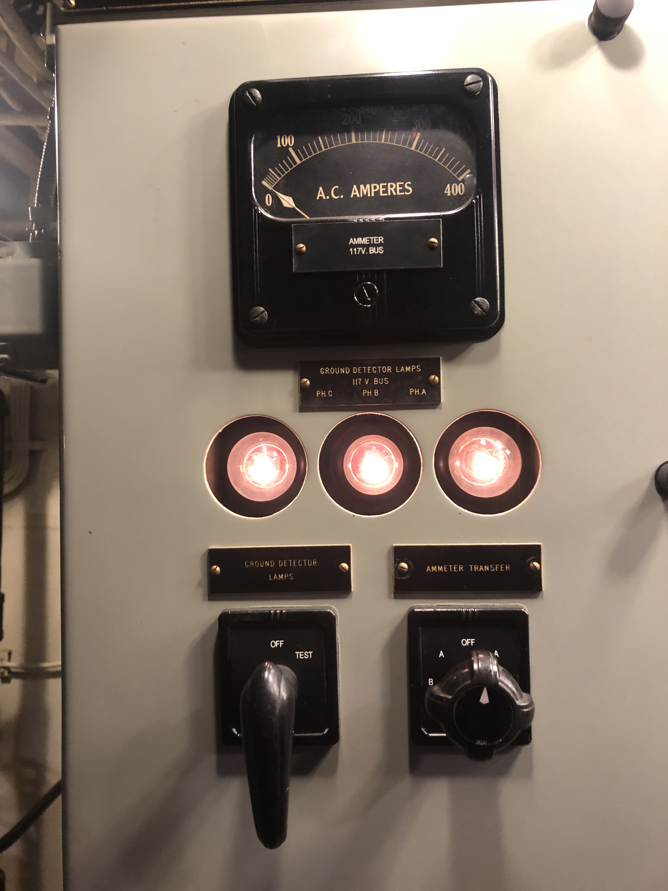
Figure 14: Ground detection lamps on USS Slater (DE-766) (photo by Norbert Doerry)
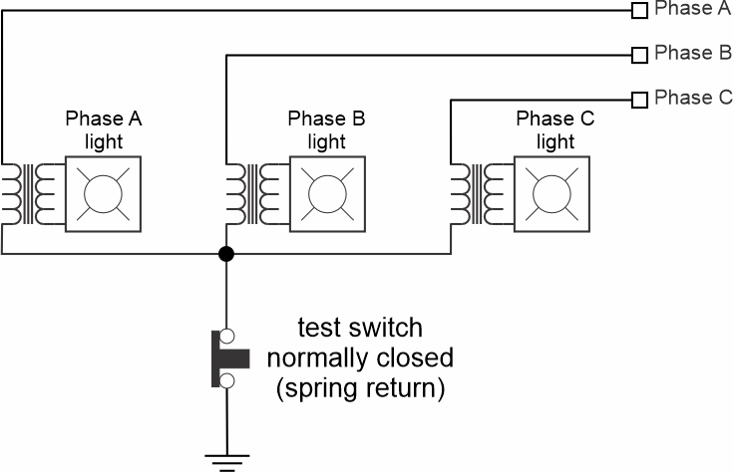
Figure 15: Ground detection lamp schematic
  - High resistance grounded systems
Ground detection lamps, or other circuits that measure the line to ground voltages of the individual phases are also effective in high resistance grounded systems. However, insulation monitoring systems are generally not applicable to high resistance grounded systems; they would measure the value of the grounding resistor.
Localizing the ground fault may use the same methods as for ungrounded systems, or alternately may include circuitry to inject a current with an audible frequency at the grounding resistor. This current may be detected with a hand-held device to trace the path to the ground fault.
Another technique is to insert a low resistance in parallel with the grounding resistor when the ship is an operational condition where the loss of power to equipment would not endanger the ship or crew. The low resistance should result in a ground fault current that is sufficient to activate the traditional coordinated fault protection system; the right circuit breaker should trip.
  - Solidly grounded systems
In a solidly grounded system, the large ground fault current activates the traditional coordinated fault protection system; the right circuit breaker should trip. One danger is that equipment critical to the current operational condition of the ship may experience a loss of power. For this reason solidly grounded systems are generally only used on circuits that do not include mission critical equipment.
- Separately derived systems
In general, separately derived systems are either completely disconnected, or connected via isolated power converters. Power systems that are connected via non-isolated power converters have a relationship between the neutral of one power system and the neutral of the other power system.
One example of non-separately derived systems is where a non-isolated dc to dc converter connecting a high resistance grounded 1000 volt dc power system (neutral normally at ground potential) with a 270 volt dc power system (neutral is directly tied within the converter to the neutral of the 1000 volt dc system). If a ground fault occurs on the negative conductor of the 1000 volt dc power system, the neutral voltage with respect to ground will rise to 500 volts dc. This means the negative conductor of the 270 volt dc system will be at 365 volts and the positive conductor at 635 volts. The differential voltage will still be 270 volts. The line to ground insulation of all the cables and equipment on the 270 volt system would have to have a voltage rating in excess of 635 volts. If the converter were isolating, an insulation rating on the 270 volt system would need only to be in excess of 270 volts.
Another example is where a passive rectifier connects an ac system with a dc system. A common mode voltage exists between the neutrals of the ac and dc systems. Under unfaulted conditions, a common mode current will flow from the rectifier, through the parasitic capacitance on the dc system, through the parasitic capacitance on the ac system, then back to the rectifier. A ground fault on the dc system will appear on the ac system as a ground fault that sequentially moves from one phase to another. The ground detection lamps on the ac system will all have the same brightness; they will not indicate that a ground fault has occurred. Ground detection lamps on the dc system will identify the ground fault.
- Grounding recommendations
As detailed by Doerry, Islam, and Prousalidis (2025) ….
- Systems with a nominal system voltage greater than 1000 volts should employ a high resistance grounded system.
- Systems with a nominal system voltage less than 1000 volts that include mission critical equipment should be either high resistance grounded or ungrounded. High resistance grounding should be used where the cable and equipment insulation is stressed by transients, high temperatures, or waveform distortion; high resistance grounding should also be used if the circuit includes many loads.
- Systems with a nominal system voltage less than 1000 volts that do not include mission critical loads should be solidly grounded to ensure compatibility with user equipment designed for the terrestrial power system.
- References
IEEE Std 45.1, IEEE Recommended Practice for Electrical Installations on Shipboard—Design
IEEE Std 45.3, IEEE Recommended Practice for Electrical Installations on Shipboard— Systems Engineering
IEEE Std 3003.1, IEEE Recommended Practice for System Grounding of Industrial and Commercial Power Systems
Doerry, Norbert, Mohammed M. Islam, John Prousalidis, Design of Shipboard Power System Grounding / Earthing, IEEE Press - Wiley, January 2025, ISBN-10 1119933080 ISBN-13 978-1119933083

